**British Council Ukraine: Procurement of Events Management Services**

The British Council in Ukraine is seeking to obtain the most efficient and effective events and conference management services for its streams of activities.

The British Council in Ukraine is looking for a maximum of two suppliers with demonstrable expertise in delivering such services to a high standard, while offering excellent value for money. The British Council will expect the supplier(s) to be able to provide the services across all of Ukraine, as well as preferably (but not essentially) in neighbouring countries, e.g. Moldova and Belarus.

If you are interested, please find the following link where details of the tender are available in addition to all documents that can be downloaded.

<https://in-tendhost.co.uk/britishcouncil/aspx/ProjectManage/1129>

In order to view and apply for the tender please follow below steps;

1. Create a log in on Intend Portal - Please note that only yellow fields are mandatory for registration information on the portal.

We recommend the suppliers to register more than one individual to minimize technology related risks.

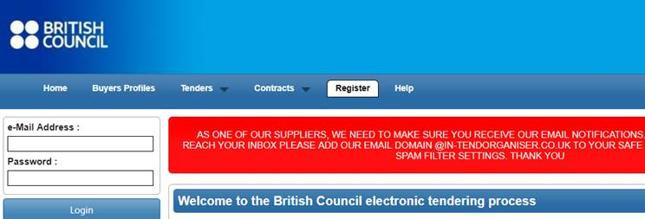

1. Click on **Current** under **Tenders Tab;**

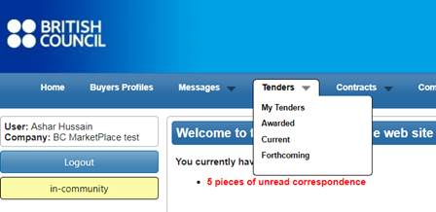

1. Click on the project title

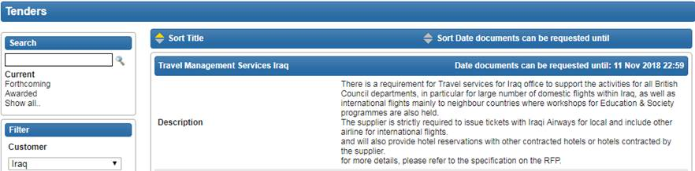

**4-** Click on **Express Interest** button at bottom



**5-** You will be able to view all the Project Details and documents under **ITT**

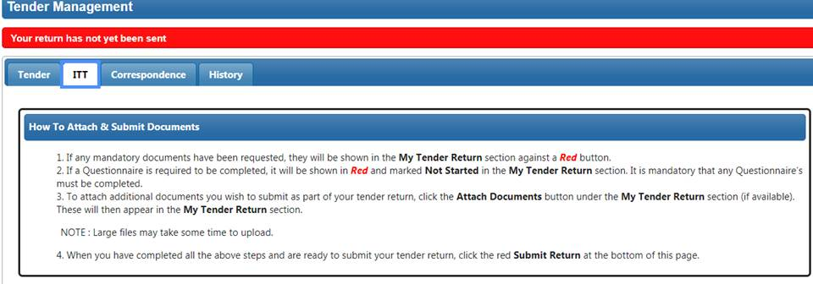

**6-** In order to submit your proposal, attach your **proposal and Bid Value** click on **Submit Return** button.

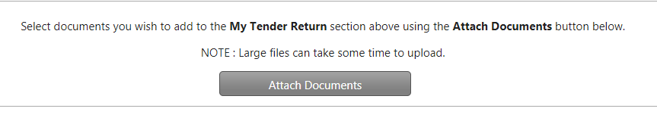

**7-** In case you want a clarification please send your correspondence to us by clicking on **Correspondence Tab**

